Q1

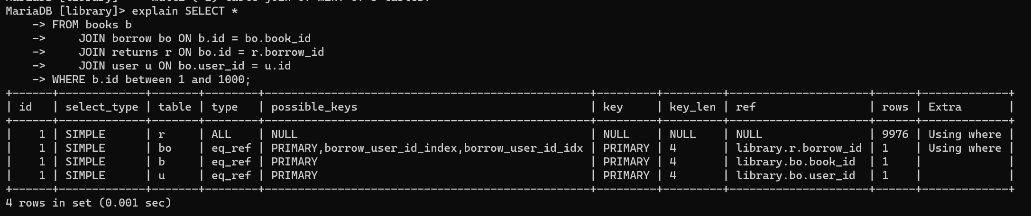

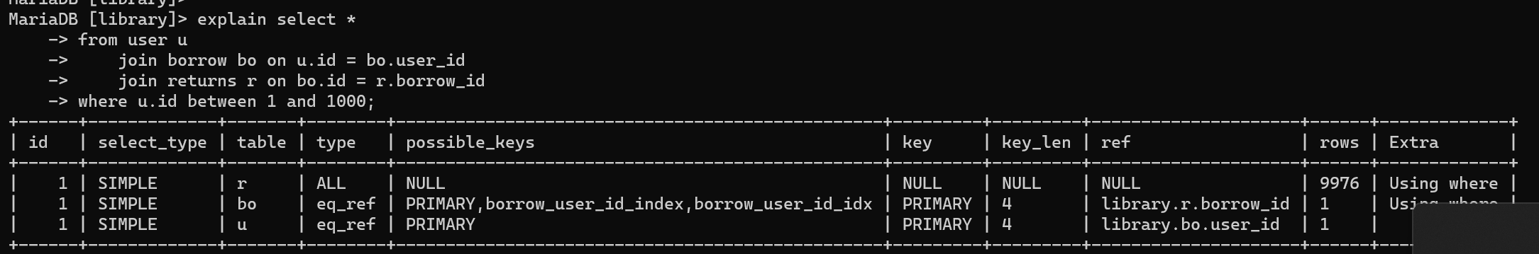

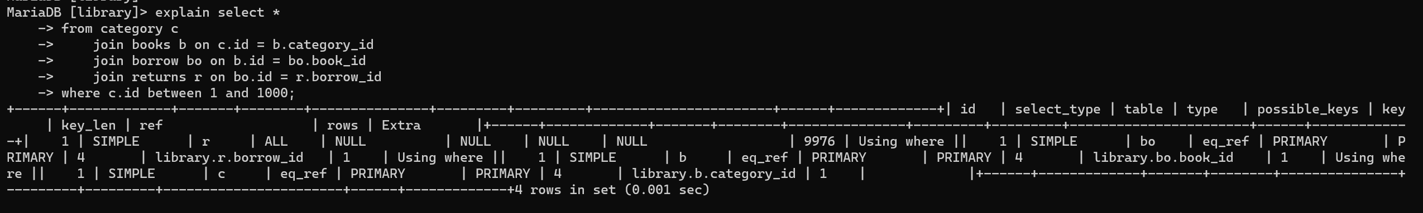

Q2

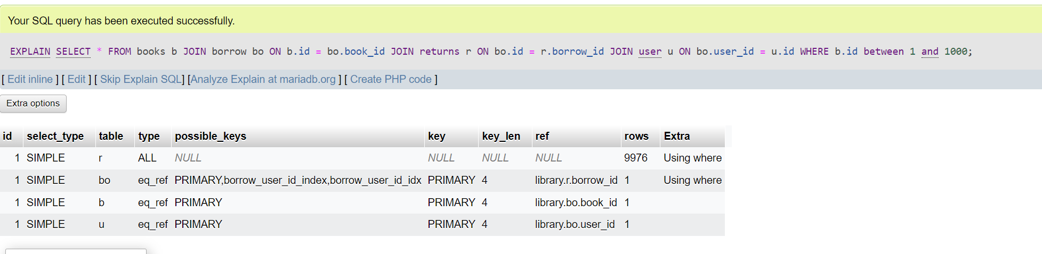

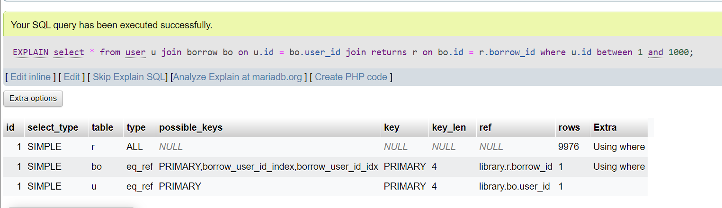

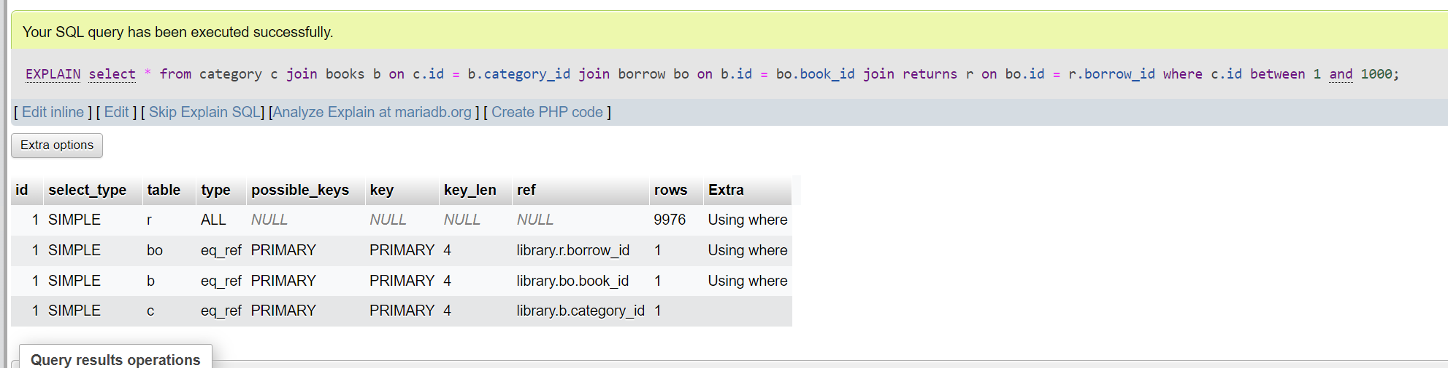

Q3

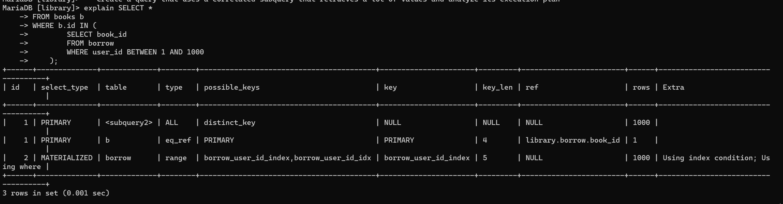

Q4

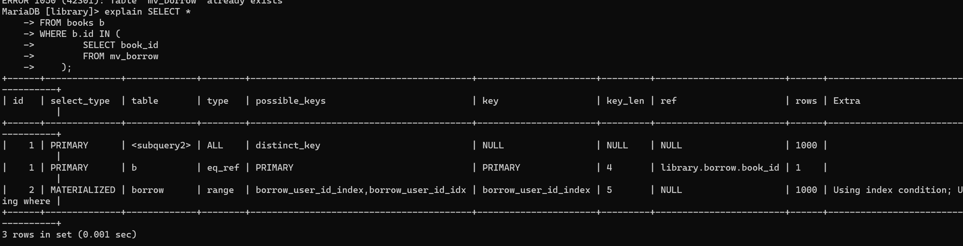

Q5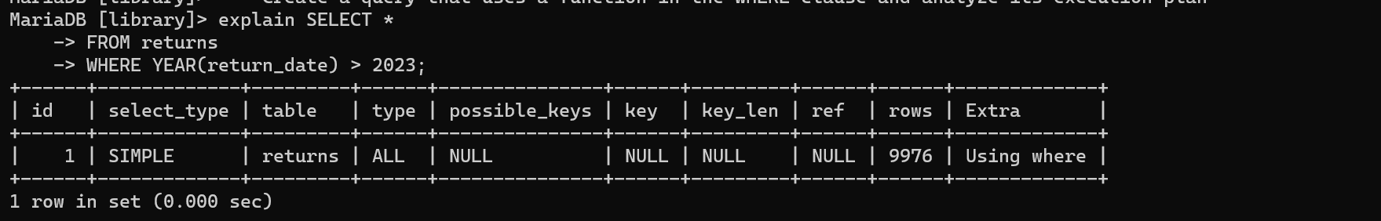

Q6

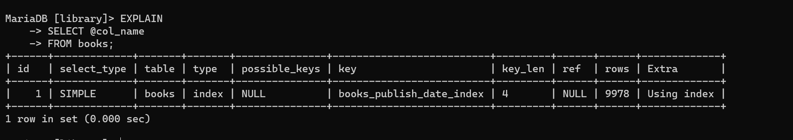

Q7

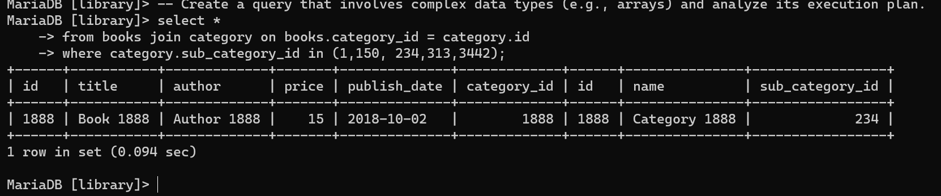

Q8

HASH INDEXING DOESN’T EXIST IN MYSQL!!!!!!!

